Payment Request Planning Phase Updated V15

1. BOB Prof Payment BP

1.1 Welcome to BRICKS!
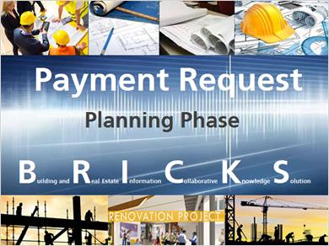
Notes:
Hello and welcome to BRICKS. In this tutorial, we are going review how to make a Planning Phase Payment Request.

1.2 About the Tutorial
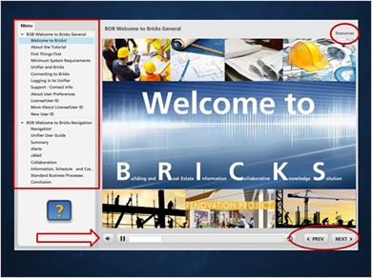
Notes:
Here are some guidelines that will help you get the most out of the tutorial. The left pane of your viewing area is a menu of the contents. You can move around within the tutorial or revisit a slide by clicking on the menu item.

All slides have player options that allow you to pause or go backward and forward within current slide.

When you see a next button, the slide is waiting on you to advance to the next one. Some slides contain lots of information, so you can decide when you're ready to go forward. You can revisit the previous slide with the previous button.

You can access any additional resources by clicking on the resources button at the top of any slide.

When you see the question mark symbol, click it to receive additional information about the related topic.

1.3 Professional Payments
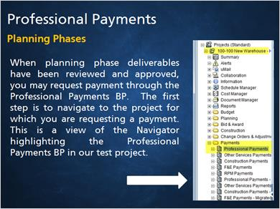
Notes:
When planning phase deliverables have been reviewed and approved, you may request payment through the Professional Payment BP. The first step is to navigate to the project for which you are requesting a payment. This is a view of the Navigator highlighting the Professional Payments BP in our test project.

1.4 Process Overview
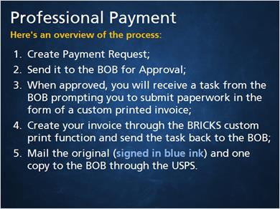
Notes:
Here's an overview of the process.
- Create Payment Request.
- Send it to the BOB for Approval.
- When approved, you will receive a task from the BOB prompting you to submit paperwork in the form of a custom printed invoice.
- Create your invoice through the BRICKS Custom Print function and send the task back to the BOB.
- Mail the original (signed in blue ink) and three copies to the BOB through the USPS.

1.5 Demo - DD Payment Request
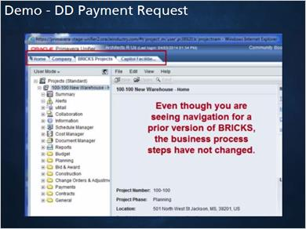
Notes:
Narration - Demo - Payment Request
Navigate to the project for which you want to create a payment request. We are in our training project. Click to expand the Payments folder and select Professional Payments. You can see a previous payment of $2,790.85 for the SD phase. You will see this number again.
In the screen that opens, select New. In the workflow picker, select Professional Payment Planning. When the form opens, click here to expand the view. Remember, red asterisks indicate required fields. Gray fields are populated and reserved by the system.
The title field is where you will put a description of the payment request. For instance, we’ll name this DD Phase Invoice.
The next required field is Reference Commit. Here you will select the appropriate professional appointment for this award. In this case, that’s PP001.
In the Award Type block, select the payment type; we’ll select Design Development phase.
In the Application/Invoice Date field, select today’s date. This picker defaults to “todays” date, so you can just click ok if you don’t need to change it.
The Application Invoice No. field number is a required field, but you can choose how to number your invoices, based on your internal tracking needs. In the Professional Award picker, select Design Development Phase Award.
In the Professional Project Number field, you can put your firm’s internal project tracking number. Select the appropriate fee schedule in accordance with your contract, or check the Appointments and Selections BP in the Bricks planning folder.
The total percent payable for the DD phase is 30%. For this project, that would be a total of $8,372.54. This is required because the percent payable field will be will be used by the custom print function in preparing your invoice.
There is no retainage in planning; put a zero in this field

Next, we need to account for previous and/or payments in progress. To find those amounts, click on the SOV button. The payments approved amount is $2,790.85. There are no pending payments. Make a note of these amounts because you will need them for the payment due calculation.
In the Previous Payments field, enter $2,790.85, the amount we got from the SOV. As we know from the SOV, there are no payments in progress.
Credits are prior payments for related services such as a pre-planning project. Or, fees paid outside of Bricks by the Using Agency. There are no credits to the Professional in this project, so we will leave that field blank.
The total due after adjustments is $5,581.69. Make note of this exact amount because it must be added as a line item to update the cost sheet and make this record actionable as a pay request.
To do that, click on Line Items to expand the block and then Add. In the window that opens, select the WBS Code picker. Highlight anywhere on this line, except for the hyperlink and select the item. Enter the Current Payment Due amount, which is $5,581.69.
Now the payment request is complete. Go to workflow actions and select Send.
You can see that the next scheduled work follow action is Send for BOB Architect Approval. To do that, you would click on the To button. In the picker that opens, highlight the appropriate name, click add and then OK. You are now ready to send the task to the BOB staff architect for review and approval. To do that, click the send button. When the request is approved you will receive a task to generate the invoice through the custom print function. That task will be titled Paperwork Submission. Let’s see what that looks like.
We are in our training project and here is our task. We could also open this task from the Home tab. Click on the task to open it.
Before you accept the task, look in Task Details to see if there is a Task Note. If there is, review it because it will disappear when you accept the task. There are no task notes.
Accept the task. Then, go to File, Print Preview, and select custom.
We are in the planning phase, so we will select INV_ Planning Professional.
Click okay and an invoice in Word format will open. Select Open from the dialog box. The instructions you get at this point may be a little different, depending on which version of Word you are using.
You can see that the invoice contains the pertinent pay request information.
Now you should print the invoice and close the word document. It is not necessary to save it.
You will be mailing your invoice to the Bureau, but you still need to advance the record in the work flow. The next scheduled action is Send for Log Invoice. Go to Workflow Actions and select Send. Open the Action Details, select Cathy Brown and then Send.
As we said earlier, you will be mailing the hard copies of your invoice to the Bureau of Building. Have the appropriate person sign the original invoice in blue ink and then make one copy. Mail the original and one copy to the Bureau of Building via the USPS.

1.6 Conclusion
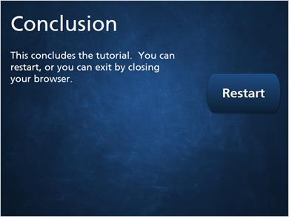
Notes:
This concludes the tutorial. You can restart or you can exit by closing your browser.

